Login.jsp

<%@ page language="java" contentType="text/html; charset=UTF-8"

pageEncoding="UTF-8"%>

<!DOCTYPE html>

<html>

<head>

<meta charset="UTF-8">

<title>Login Page</title>

</head>

<%@include file="component/allcss.jsp" %>

<style type="text/css">

.back-img{

background:url("img/phone.png");

width:100%;

height:100vh;

background-repeat:no-repeat;

background-size:cover;

}</style>

<body>

<%@include file="component/navbar.jsp" %>

<div class="container-fluid back-img text-center text-success">

<h1 class="">Login Here</h1>

<%@include file="component/loginform.jsp" %>

</div>

<%@include file="component/footer.jsp" %>

</body>

</html>

Login.jsp

<form class="w-50 mx-auto" action="/login" method="post">

<div class="mb-3">

<label for="exampleInputEmail1" class="form-label">Email address</label>

<input type="email" name="email" class="form-control form-control-sm" id="exampleInputEmail1" aria-describedby="emailHelp">

<div id="emailHelp" class="form-text">We'll never share your email with anyone else.</div>

</div>

<div class="mb-3">

<label for="exampleInputPassword1" class="form-label">Password</label>

<input type="password" name="password" class="form-control form-control-sm" id="exampleInputPassword1">

</div>

<button type="submit" class="btn btn-primary">Submit</button>

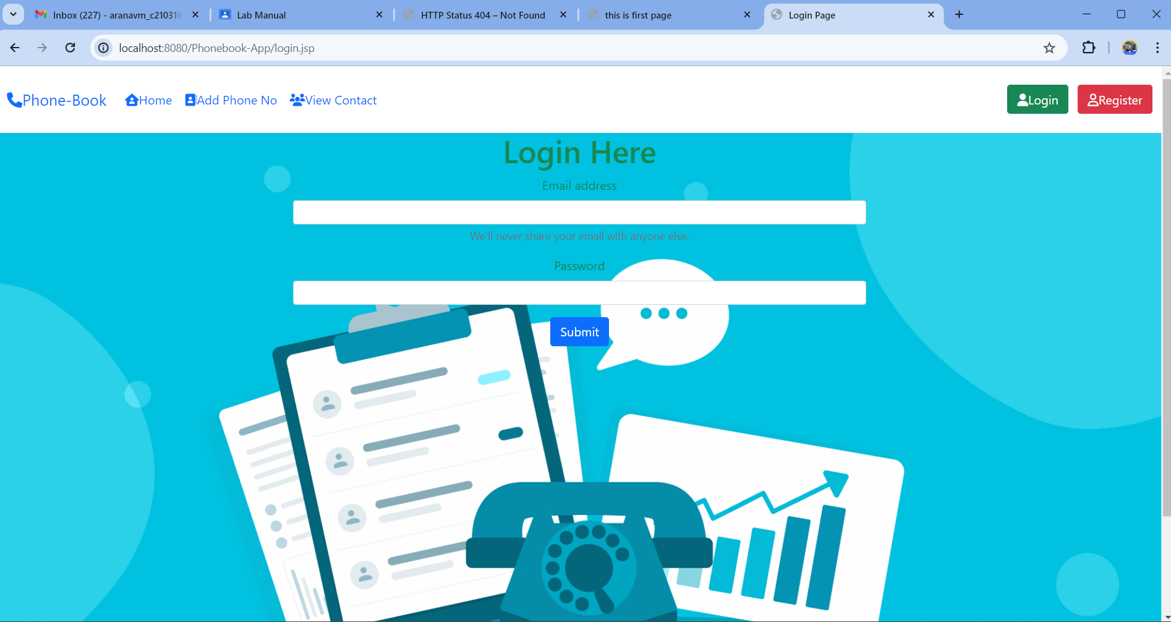</form>